1. **INTERNAL INVENTORY ISSUANCE**
   1. Issuing out of specific items is handled by this department. Such items will have to be attached to a Logical Warehouse in SAGE named "ADMIN". Procurement team will source the items into Master Warehouse and then do a Warehouse transfer into ADMIN warehouse. ICT will link ADMIN Warehouse to the module from settings section. From this point, all the items linked to this warehouse will be listed in ADMIN module.
   2. There will be a screen for listing Items + Qty.
   3. Requisition could be raised by any staff with access rights to this module.
   4. ADMIN staff will check the available quantity and issue the items. The following information needs to be recorded in this form:
      1. Requisition by - Staff details as pulled from HR App
      2. Req. date
      3. Items required by - date
      4. Item name - picked from item list as mentioned in Point (1) – query provided filter for warehouse code selected on setting question.
      5. Qty Requested
      6. Qty Available - Only visible to ADMIN staff
      7. Project name - Cost centre – Picked from SAGE
      8. Purpose - Optional
   5. ADMIN will issue the items as applicable. The issuance page will list all requisitions. The Admin will click on a requisition and this opens Requisition form with full details (including Qty available). There will be an additional textbox available here called “Qty Issued”. This textbox will by default have Qty Requested or Qty available whichever is less. The Admin can change this value to less qty but not more. If less qty is issued then a reason needs to be given. Once issue button is clicked, the requisition status changes to “ISSUED” and does not show up in requisition listing.
   6. Once the admin clicks on “ISSUE” button on Issuance Form, the module invokes Update Stored Procedure to push the entries into SAGE Inventory Batch.
   7. Once the items are issued, the requisitioner will get an email advising to collect the items from Admin.
   8. The requisitions with status = ISSUED will get listed in another page titled “DISBURSED REQUISITIONS”. When the staff comes to collect the items, the Admin will locate such requisitions on this page and open it as Read-Only format. The requisition will be printed and given to staff for signing(provide the pdf format). The Admin hands over the items to the staff and files the print out. At this point the requisition Status is changed to “DISBURSED” is moves out of this page.
   9. Re-order Level: Each item will have its re-order level maintained in SAGE. A daily report will be generated listing any items that have fallen below re-order level. Also there will be an Ordering form on which such items will be listed. ADMIN staff can select which items to be ordered / replenished. It will have the following form layout. When “Request” button is clicked, a Procurement Requisition is raised using WebAPI. The status of such requests is set to “REQUESTED”. These items will no longer appear on this form. There will be a table showing “Requested” items.

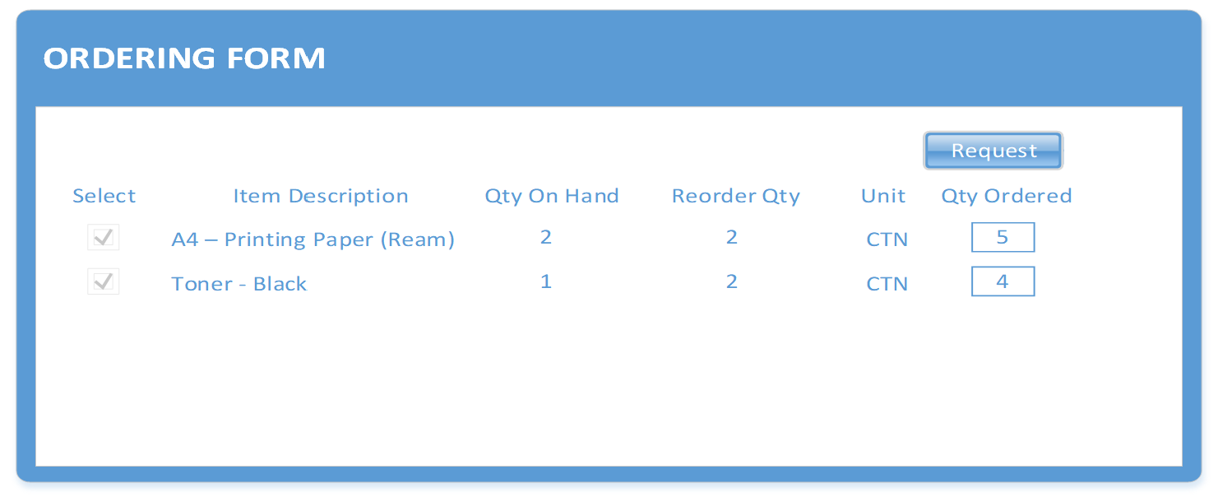

1. **DOCUMENT HANDLING**
2. The documents will be recorded in table as they are received and dispatched.
   1. Receiving / Dispatching:
      1. The ADMIN staff will add the following details for each document received. Option is selected for Receiving / Dispatching.
      2. When the SAVE is clicked, an email is sent to the STAFF informing that a document is received.
      3. When the document is delivered to Staff by Admin or the Staff collects it, the Admin will open this form again and click on the Check Box “Document Delivered”

